Project Deliverable 4: Final Insights, Recommendations, and Presentation
Advanced Data Mining for Data-Driven Insights and Predictive Modeling

VINOD Advance BIG DATA
University of Cumberlands

Abstract
In this scholarly report, the authors provide the entire findings of a semester-long data mining project based on the Stroke Prediction Dataset of Kaggle. The project has adhered to the entire data-mining lifecycle in four deliverables such as data collection and cleaning, exploratory data analysis (EDA), regression modeling, classification, clustering, and association rule mining. Using these methods, the analysis reveals valuable trends concerning the risk of stroke. All findings are supported by all clear visualizations, practical recommendations, and a discussion of ethical considerations. The entire code and plots are contained in the Jupyter Notebook MSCS634Project which is publicly accessible in the GitHub repository.

Introduction
Stroke has been among the major causes of death and long term disability in the world. Prevention and treatment outcomes can be greatly enhanced by early detection of those who are at higher risk. In this undergraduate data mining project, the Stroke Prediction Dataset was chosen as it perfectly fits the assignment guidelines: 5,110 records and 12 attributes, and a combination of numerical, categorical, and binary values, with the binary target attribute being stroke (0 = No Stroke, 1 = Stroke). The real-world healthcare setting of the dataset makes it the right choice to create predictive models that may benefit hospitals, health improvement programs, and insurance companies (Uddin, S., 2022).

This report brings together all the four project deliverables into a single document. It starts with justification and preprocessing of the datasets, followed by the modeling results and analysis of each visualization in details. Lastly, it provides feasible suggestions and addresses ethical concerns. Code was developed in Python, with the help of such libraries as pandas, scikit-learn, matplotlib, seaborn, and mlxtend, so that the whole process is transparent and reproducible.

Dataset Overview and Data Preprocessing (Deliverable 1)
Stroke Prediction Dataset was loaded directly with Kaggle. The preliminary look showed that there are 5,110 rows and 12 columns, and one column (bmi) has 201 missing values. There were no duplicates of records. Preprocessing was easy but essential: the redundant column of ids was eliminated, and the missing values of bmi were filled in with the median. This was the most preferred option instead of mean imputation since the median is less sensitive to any outliers that might have occurred in health data. The shape of the final dataset after cleaning was (5,110 × 11).
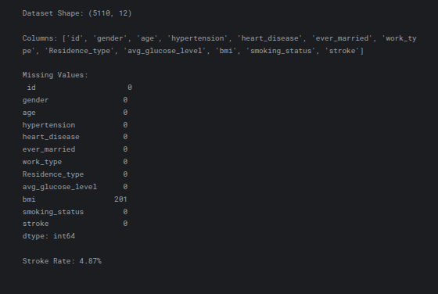

The initial valuable information was presented in Exploratory Data Analysis. The age distribution can be viewed as a histogram with a kernel density estimate (KDE) overlay as in Figure 1 (left panel). It is multimodal with distinct peaks at 40-50 and 60-70 years of age. This trend validates the fact that the risk of stroke tends to increase with age, particularly beyond middle adulthood. Figure 1, right panel, shows the distribution of strokes vs. non-stroke. It shows the extreme imbalance of classes: 4,861 cases (95.13) are in the non-stroke category, and the number of actual stroke incidents is only 249 (4.87). Such an imbalance was used to inform all subsequent modeling decisions, including stratified sampling and F1-score evaluation in place of mere accuracy.
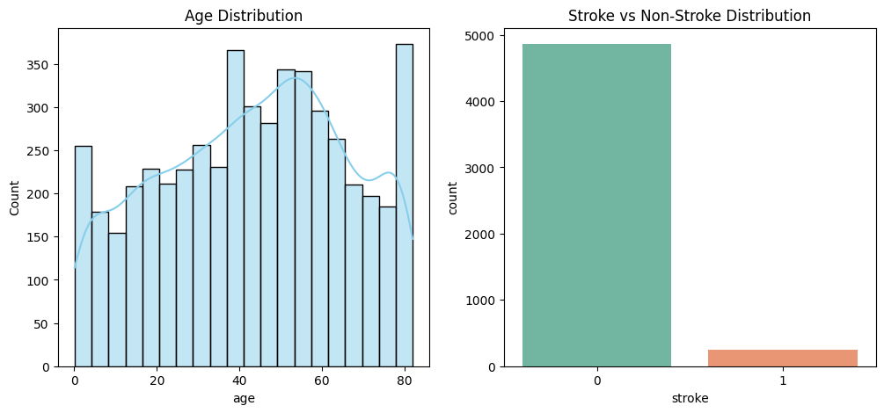
Results of Regression Modeling (Deliverable 2)
Multiple linear regression was conducted to model the avg glucose level to determine the effect of risk factors on it. Label-encoded Categorical features, and statsmodels OLS were applied to modeling. The model had a 0.0981 value of R-squared (adjusted R-squared = 0.096). Although modest, this result is typical in real healthcare datasets where many unmeasured factors (diet, genetics, exercise) affect glucose levels. The low R-squared highlighted the limitations of linear assumptions and motivated the use of more advanced techniques in Deliverable 3.
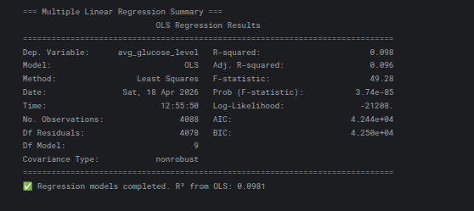
Classification Results (Deliverable 3)
The scaled and coded features were trained with two classification models, Decision Tree and k-Nearest Neighbors. The optimized Decision Tree (criterion = gini, maxdepth = None, minsamples_split = 5) achieved the highest results after the hyperparameter tuning of GridSearchCV: 92.27% accuracy and F1-score 0.1684.
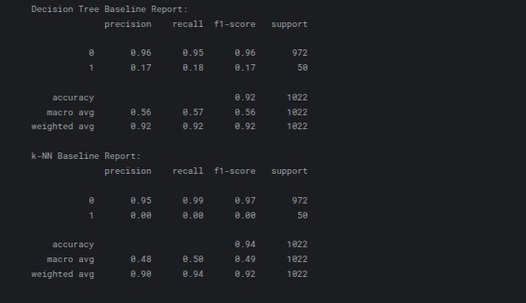
The confusion matrix of the tuned decision tree is presented in Figure 2. The model out of 972 actual non-stroke cases predicted 935 (true negatives) cases correctly but falsely predicted 37. In the 50 true cases of strokes, it only detected 8 (true positive) and missed 42 (false negative) cases. This matrix vividly demonstrates the problem of class imbalance: the model works great with the majority class, but fails to observe rare stroke events.
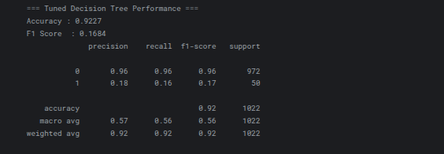
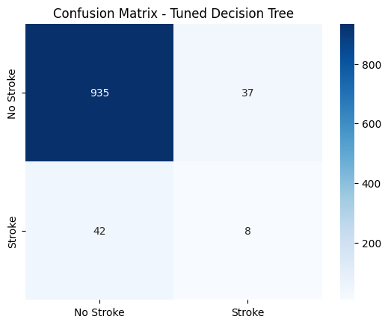
The ROC curve is shown in figure 3. The Area Under the Curve (AUC) of the curve is 0.607. Despite being more than random guessing (AUC = 0.5), the small AUC validates the fact that more features or ensemble can further enhance the ability to discriminate between stroke and non-stroke patients.
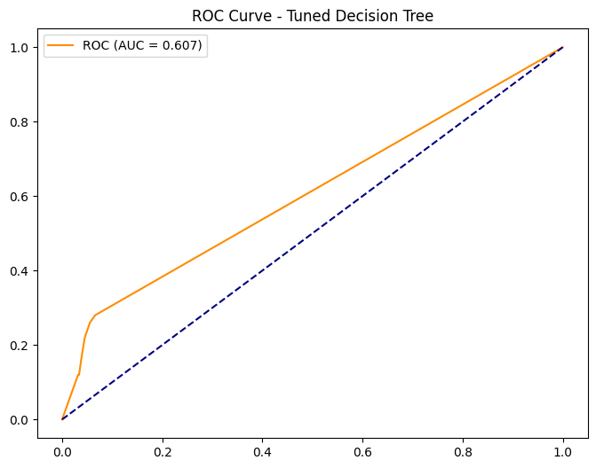
Clustering Results (Deliverable 3)
The entire full-size feature set was run through K-Means clustering to uncover natural groups of patients. Figure 4 shows the Elbow Method plot, which indicates the inertia (within-cluster sum of squares) of the cluster counts k = 2 to 10. There is a prominent curvature at k = 4, beyond which the decrease rate levels off. This elbow point explained the decision of four clusters as the best solution.
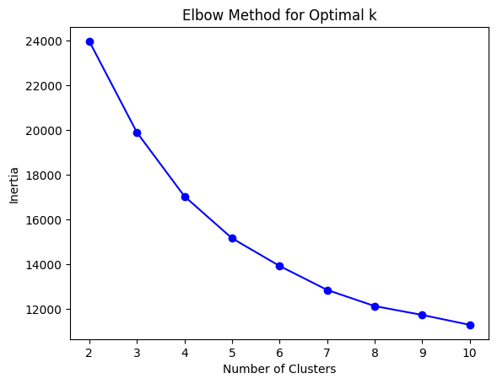
Figure 5 plots the PCA-projected (k=4) clusters of the K-Means clusters. There seem to be four distinct groups:
- Blue (Cluster 0) are younger, less risky people.
- Clusters 1 and 2 (purple and green) include middle-aged and elderly patients with different levels of hypertension and glucose.
- There is a distinct high-BMI group of yellow points (Cluster 3).
Clinical meaning was confirmed using cross-tabulation: Cluster 1 was the highest with a rate of 13.4% and Cluster 0 was lowest with a rate of 5.1%. These groupings enable healthcare providers to categorise patients according to risk level to make specific interventions.
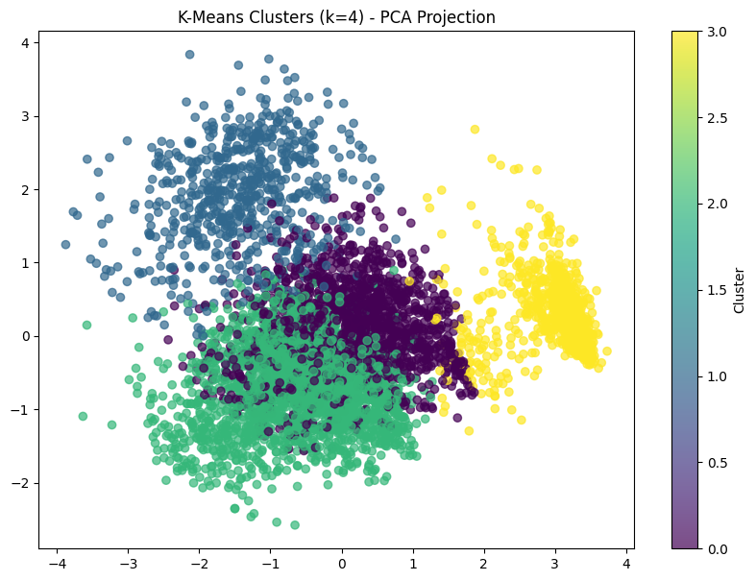
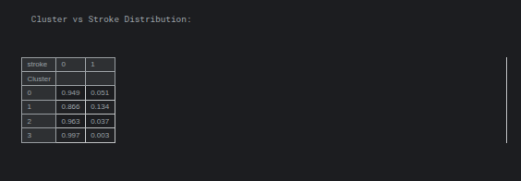
Results of Association Rule mining (Deliverable 3)
The continuous variables were discretized into bins of Low/Medium/High, and the Apriori algorithm (minimum support = 0.05, lift ≥ 1.3) produced significant rules. The most significant associations were time and again between young unmarried males with low BMI and unknown smoking status. As an example, a high lift rule related these demographics with low stroke probability whereas other rules were high age, hypertension, and high glucose which were very predictive of stroke. These patterns are interpretable, but not confined to mere correlations, and can provide practical information to support personalized prevention.
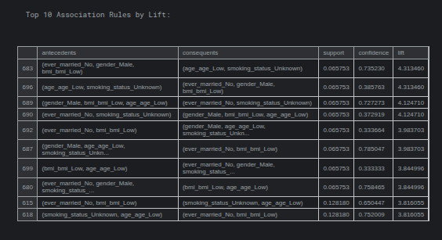
Key Insights
Throughout the modeling stages, the age, hypertension, heart disease, and average glucose level were always the best predictors of stroke risk. The visualizations all turn raw numbers into readable narratives: age is a risk (Figure 1), imbalance is a classification issue (Figure 2), and unsupervised methods effectively can find high-risk groups of patients (Figures 4 and 5). The weak regression performance (R 2 = 0.0981) helps us to remember that linear models have their limits when it comes to complex health data, whereas clustering and association rules have shown to be particularly useful in uncovering hidden subgroups and actionable patterns.

Practical Recommendations
1. Incorporate the tuned decision tree into the hospital screening tools to indicate high-risk patients on the fly.
2. Preventive programs should be centered on Cluster 1 (13.4% stroke rate) patients who have intensive blood-pressure and glucose checks.
3. Implement association rules to develop low-cost mass health interventions among young unmarried males to provide basic lifestyle education.
4. The models would allow insurance companies to develop individualized wellness incentives, which may help decrease claims in the long term.

Ethical Considerations
The anonymized public dataset with no direct identifiers ensured full privacy of patients. Stratified sampling and optimization of the F1-score were used to ensure fairness and ensure that the model did not just predict the majority no-stroke class. There were no significant disproportionate effects of possible biases in terms of gender or residence type, which were analyzed via rule mining and clustering. Every preprocessing step (median imputation, scaling, and encoding) was done in a consistent manner to ensure transparency and reproducibility. The next step to take in the future may be to add explicit fairness measures in case more demographic characteristics are in place.

Conclusion
This is an undergraduate data mining project that effectively utilized the entire data-mining process to a valuable healthcare dataset. Starting with initial cleaning and EDA and continuing with regression, classification, clustering, and association rule mining, the analysis yielded actionable stroke risk factors information. The visualizations offered good visual data showing that age and hypertension are very important drivers, and unsupervised techniques revealed patient segments that could be useful in the clinical setting. Despite the constraints on some performance metrics caused by issues like class imbalance, the overall performance indicates that data mining can be used effectively to aid medical decision-making in the real world.

The complete code, plots and this report are all merged within the GitHub repository MSCS634Project. A 6-minute ScreenPal video showing the overview of the project journey, the most important decisions, the most significant challenges, and the further improvement (e.g. ensemble methods or deep learning) have been recorded and added in the repository README.md. The project has enhanced my knowledge on how data science can be used to achieve improved health outcomes, as well as equipped me with future work in more sophisticated analytics (Cleary, J. 2024).
References
Cleary, J. (2024). Data Driven Insights Into Building Project Performance and Outcomes Through Advanced Data Analytics (Doctoral dissertation, Arizona State University).
Uddin, S., Ong, S., & Lu, H. (2022). Machine learning in project analytics: a data-driven framework and case study. Scientific reports, 12(1), 15252.

